Stay Strong Requirements

Admin Portal Requirements:

*Assumptions:*

* Vibrent system admin will create accounts for all team members that need access to the portal for launch.
* Once the admin selects the checkbox on the portal, they will be presented with a message to confirm the selection. Once they do, they will not be able to uncheck this option.
* Research Arm assignments will not be changed once a participant has been assigned.
* Program lasts 12 months plus 30 days (the extra 30 days is to allow for collection of data especially from people who may not be active prior to ending date).

1. **Sign in Screen:**

|  |  |  |  |
| --- | --- | --- | --- |
| **Req No.** | **Requirement** | **Details** | **Acceptance Criteria** |
|  | Sign In UI  *Refer to UI mock below* | Admins should be able to see a Stay Strong Logo on the screen along with Email address and Password options to Sign In | 1. Admin Portal should be optimized for Internet Explorer v11 2. Stay Strong Logo should be displayed on the screen 3. Users should enter their Email address and Password 4. Users should click on “Sign In” once they have entered their credentials |
|  | Admin/Coach Portal Sign in | Admins, Coaches and Researchers should be able to log into the web portal, to manage users and view participant data | 1. Users should enter an email address 2. Users should enter Password 3. Passwords should be a min of 6 characters 4. Users should click on “Sign In” button to authenticate. |
|  | Password reset | Admins, Coaches and Researchers should be able to reset their password using “Forgot your Password?” link | 1. “Forgot your Password” link will show up on the Sign In screen below 2. When a user clicks on “Forgot your Password” they should receive an email with a reset password link 3. The reset email password should be sent from a [no-reply@vibrent.com](mailto:no-reply@vibrent.com) |

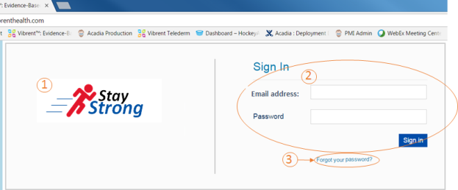

1. **Dashboard View (User Management):**

|  |  |  |  |
| --- | --- | --- | --- |
| **Req No.** | **Requirement** | **Details** | **Acceptance Criteria** |
|  | Dashboard/ User Management view columns  *Refer to UI mocks* | Users with access to the Admin portal should be able to view all participants along with certain data for each participant | 1. When a user logs into the Admin portal, they will be able to see a User Management Dashboard with the following columns:    1. Username    2. Vibrent ID (system generated)    3. Program Code/Password    4. Start Date (Date Status changes to Randomized)    5. Days in Program (calculated starting from Start Date)    6. Welcome Packet sent? (checkbox)    7. Status (system populated based on workflow)    8. Research Arm (user selection from drop down)    9. Disposition (user selects from a drop down)    10. Qualtrics Survey Status (2 checkboxes manually populated) - added 03/31   ***NOTE:*** *Individual field requirements below in in this section* |
|  | Participant data population | Once a participant downloads the app and signs up on the app (entering the password which is same as the Program code assigned to them), their information will be systematically entered in the Admin portal.  *NOTE: Participation Authentication requirement is in the Participant section below* | 1. When a user Signs up, their information is systematically updated in the Admin Portal. 2. Fields populated upon initial sign up would be as follows:    1. Username    2. Vibrent ID (system generated)    3. Program Code (Password    4. Status: Ready for Packet    5. Disposition: None 3. All other fields will be blank initially |
|  | Program Code | Vibrent will be given a list of valid program codes from the Stay Strong team. One code is sent out to each candidate participant in a mailed recruitment letter. Participants will use their assigned Program code as their password to authenticate. | 1. When a user downloads the app and signs up, they use their assigned Program Code as password. 2. System must validate that the Program code entered by the user exists in our system before saving this code to the Admin Portal. 3. If the Program Code is valid then it will be saved to the user’s entry in the Admin screen. |
|  | Start Date | Start Date is the date the user is Randomized | 1. When a participant initially signs up the start date is blank 2. Start Date should be populated with the date when the Status changes to “Randomized”   NOTE: Status gets systematically updated to Randomized once the Admin assigns a Research Arm to the participant |
|  | Days in Program | Days in program is the number of days that participant has been in the program starting from the Start Date.  NOTE: This is not the same as app download date. | 1. Days In Program should be the number of days the user has been in the program beginning from the “Start Date”. 2. This field will change daily to account for the current day starting from when the Start Date is populated. 3. If the Start Date is blank the Days in Program value will also be blank.   NOTE: Start Date is systematically populated once the Status of the participant changes to Randomized |
|  | Welcome Packet Sent | Admin should be able to indicate on the portal if a Welcome Packet has been mailed to the participant | 1. This field is a check box 2. When a participant signs up this box should be unchecked initially 3. Admin should manually check this field once they have mailed the welcome packet. 4. When Admin checks the box, they should be provided with a pop up “Selecting this confirms devices have been mailed to the participant. The Status of the participant will change to “In Progress” Do you wish to Continue?”    1. If Admin selects Yes, changes are saved and Status is changed.    2. Once the changes are saved, Admin cannot update this box again.    3. If Admin selects No changes are not Saved 5. When this checkbox is selected, the value in the Status column should automatically change to “In Progress” |
|  | Status | Status should be systematically changed for the participant based on the participant or Admin activity. | 1. The following are the values for the Status field:    1. Ready for Packet    2. In Progress    3. Ready for Randomization    4. Randomized    5. Completed   NOTE: Rules on which status should be assigned are listed below. Also, refer to the Program Flow chart   1. Admins should not be able to manually make updates to the value in this field. 2. Any updates to this field is systematic |
| 7a | Ready for Packet | 1. When a participant downloads the app and signs up using the valid program code the Status is set to “Ready for Packet” |
| 7b | In Progress | 1. Status= ”Ready for Packet” will alert Admin to send out a welcome packet to participant (Mailing is not done within the system). 2. When an Admin selects the checkbox on “Welcome Packet Sent” column the Status should automatically change to “In Progress” |
| 7c | Ready for Randomization | 1. Participant successfully pairs their fitbit and scale and starts using their fitbit to track their steps. 2. Once the participant receives their initial baseline goal, the status should change to “Ready for Randomization”   NOTE: Requirements on how they reach the initial baseline goal is listed in the “Stay Strong Goal Algorithm” section below |
| 7d | Randomized | NOTE: Admin Randomizes the participant into either Intervention or Control Arm once their status is changed to Ready for Randomization. Randomization happens in a system outside of Vibrent.   1. Admin manually updates the Research Arm drop down (Step 8) to either Intervention or Control based on the Randomization 2. When the Research Arm value gets populated with either Intervention or Control, the Status should be changed to “Randomized”. |
| 7e | Complete | 1. After 12 months + 30 days from the participant’s start date, Status should automatically change to “Completed” 2. When Status is changed to Complete, Participant will receive a splash screen thanking them for their participation. See screens/specifications in Sections 9 & 10 below |
| 8 | Research Arm | A participant will be assigned either an Intervention or Control Arm based on the Randomization done by the Admin (outside of Vibrent) | 1. The following are the options in the Research Arm drop down:    1. Control    2. Intervention 2. The system should automatically save the Research Arm values for each participant. 3. Once a selection has been made, this cannot be changed by the Admin in the future. 4. Based on the Arm (Control or Intervention) selected by the Admin, participant receives Wall message (part of 9.3) |
| 9 | Disposition | A participant will call and let the Admin know if they would like to be withdrawn from the Program or if they are suspended due to medical reasons | 1. The following are the options in the Disposition drop down:    1. None    2. Suspended    3. Withdrawn 2. Admin will manually change this status to either Suspended or Withdrawn based on a call initiated by the user. 3. Admin should be able to reset to any of the Status choices. (e.g., from Suspended to None.) 4. If Status is changed back to “None,” program will be unlocked again based on Research Arm   NOTE: Requirements for Suspended and Withdrawn are below |
| 10 | **ADDED on 3/31:**  Qualtrics Survey Status | Participants are asked to take a survey at 6 months and 12 months in a survey site that is outside of Vibrent. On the client requirements under Survey Reminder section (Administrative messaging) ,Vibrent sends a reminder to the participant to take the survey. Vibrent does NOT need to integrate with this site to get any responses. | 1. Add a new column 'Qualtrics Survey Status' on the User Management Dashboard. This column will have 2 check boxes:    1. 6 month survey complete    2. 12 month survey complete 2. These checkboxes will be manually selected by the administrator 3. By default neither checkbox is selected 4. Admin should be able to select both the checkboxes 5. Notifications based on changes to this will be sent to the client (covered in the Client Requirements → Survey Reminder section) |

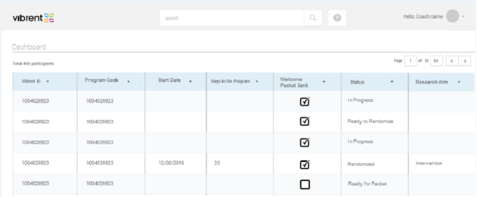

1. **Dashboard View (Data Visualization):**

|  |  |  |  |
| --- | --- | --- | --- |
| **Req No.**  1.4 | **Requirement** | **Details** | **Acceptance Criteria** |
|  | Data Visualization | Admins and Coaches should be able to view user data in various charts | 1. When an Admin or Coach clicks on the participant’s name on the User Management screen (Section 2), they will be taken to the Dashboard view. 2. Admins and Coaches should be able to see bar graph view per user. 3. The following charts should be available: (Mock attached for Active Minutes. Other should follow the same pattern)    1. Active Minutes    2. Heart Rate    3. Steps    4. Weight    5. Miles    6. Stairs 4. The above charts should available for the following intervals:    1. Weekly view (current and previous weeks). When the Admin clicks on the arrows they will be able to navigate to other weeks.    2. 4 week view 5. Admins and Coaches should be able to click on the drop down and change the interval view to see the data for a certain period. 6. For Intervention Arm participants, ONLY, a goal line should be visible on the bar graphs 7. Another "line" (finer/less distinct than the goal line) that will be estimated based on the minutes of moderate to vigorous activity/day (Active Minutes)- showing whether trending down, up, plateau - based on the average trajectory over time; this regression over time based on data will be visible for Intervention Arm only. |

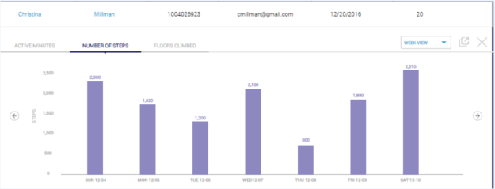

1. **Reports (User data: login dates, fit bit sync, everything uploaded by the user)**

|  |  |  |  |
| --- | --- | --- | --- |
| **Req No.** | **Requirement** | **Details** | **Acceptance Criteria** |
|  | Reports | Admins and Coaches should be able to export reports on participant data | 1. Admins and Coaches should have access to a Reports tab 2. The following participant data should be available for each participant:    1. Weight    2. Program Code    3. Account Set up Date    4. Packet Sent Date    5. Baseline Goal    6. Start Date    7. User Status    8. Status Change Date: (This should the date for each status change)    9. Research Arm    10. Research Arm assignment date    11. Disposition    12. Disposition Change date    13. Weekly Goal    14. User log in dates    15. Active Minutes    16. Number Rate    17. Miles    18. Stairs    19. Weight sync date    20. Weight    21. Survey Responses (Intervention Arm ONLY). Control Arm users should not see this column    22. Survey Date (Intervention Arm ONLY). Control Arm users should not see this column |
|  | Export | Admins and Coaches should be able to export the data | 1. Admins and Coaches will export the data in .csv 2. Admins and Coaches will be able to export based on the following filters:    1. Date Range    2. User 3. The export will have a maximum of X rows.    1. Admin should also have the option to export all the raw data in an export   Details to be provided by tech team. |

1. User Login Requirements:

*Assumptions*

1. A list of Program Codes will be provided to Vibrent from Stay Strong Team
2. Participants will each receive one of these same Program Codes in their recruitment letter
3. There is no password reset. If participants don't know the Program Code they will be directed to call an Admin to get this code.
4. The mapping of users and codes will not be maintained within Vibrent or in the Admin Portal

|  |  |  |  |
| --- | --- | --- | --- |
| **Req No.** | **Requirement** | **Details** | **Acceptance Criteria** |
|  | Sign Up Screen | Participants should download the app and enter the Program Code provided to them in their recruitment letter | 1. Once the participant downloads and launches the app, they will be taken to the Log in screen. 2. Participants click on Sign Up and be taken to the Registration screen. |
|  | Forgot info? | Participants should be able to get help with credentials if they don't have their Program Code | 1. Participants will have the option to select on "forget info?" to get more information 2. When participants click on "forgot info" they will be provided with a phone number they can call to get their program code. See text below. 3. This information will be presented to them as a message on the same screen |
|  | Registration Screen | Participants should enter their information to register for the Program | 1. Participant will enter the following required fields:    1. Username (VA Team will prompt users to enter nickname – not their real name)    2. Program Code    3. Re enter Program Code 2. Next to the Program Code, participant will see an information icon. 3. When a participant clicks on the icon, they will see a message on the screen explaining to them what the Program code means. See text below. 4. If the program code is not valid (i.e., if it does not match an entry in Vibrent system), they will receive an error message “Program code invalid, please re enter. If you do not know your Program Code, please call 800-753-3357753-3357.” 5. Participant will be required to check on the Terms of Service and Privacy Policy radio button 6. If a participant does not select this radio button and click on Next, they will receive a message "Please agree to the Terms of Service and Privacy Policy" 7. Participants will be able to click on the Terms of Service and Privacy Policy hyperlinks and be directed to Vibrent Terms of Service and Privacy Policy screen (we should use the existing one from Acadia) *Please provide copy to VA Team.* 8. If the Program code is valid, they will be taken to the Welcome screen |
|  | Welcome wall message | Participants should see a welcome wall message | 1. Participants will be taken to their wall with a welcome message after they have successfully registered. 2. Participant should be able to click on the Hamburger menu to view their menu options. |
|  | Keep me logged in | Returning participants will be able to log in using re saved their program code | 1. Participants will enter just their Program Code to log into the app. 2. Participants will have the option to select on “Keep me logged in” on the Login Screen and remain logged in. 3. When Participant returns to the app they will be taken directly into the App |
|  | Hamburger Menu | Participants should be able to navigate within the app using the hamburger menu | 1. When a participant clicks on the Hamburger menu, they will see the following menu options:    1. Dashboard    2. Apps & Devices    3. Support    4. Log Out   NOTE: Requirements for each of the menu options are listed in the following sections. |

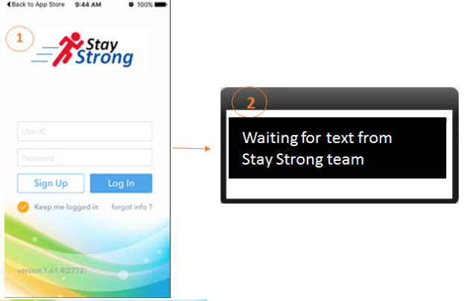

Username (do not use your real name)

Stay Strong Code (password)

*If you have forgotten your Stay Strong Code or have any questions, Please call 1-800-753-3357, Option 3*

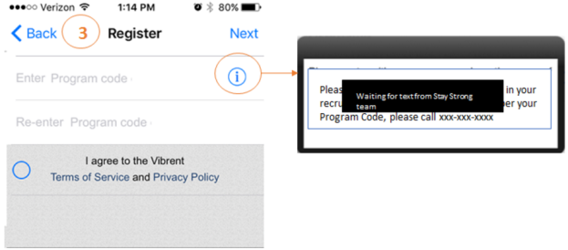

*If you have forgotten your Stay Strong Code or have any questions, Please call 1-800-753-3357, Option 3*

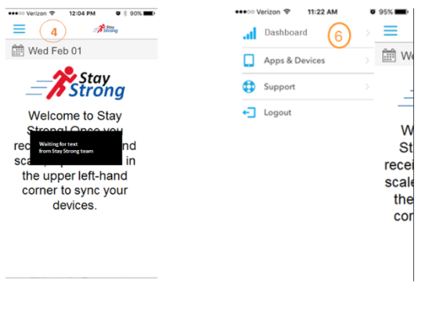

*Welcome to Stay Strong!*

*Your package is on its way! [New line]*

*When you receive your Fitbit and scale, tap the menu in the upper left-hand corner to set-up and sync.*

**7. Support Screen Requirements:**

|  |  |  |  |
| --- | --- | --- | --- |
| **Req No.** | **Requirement** | **Details** | **Acceptance Criteria** |
|  | Support | Participants should be able to access FAQs in case of any questions | 1. Participants will click on Support from the hamburger menu to be taken to the Support screen 2. Support page should have list of FAQs **<Text to be provided by Stay Strong team>** |

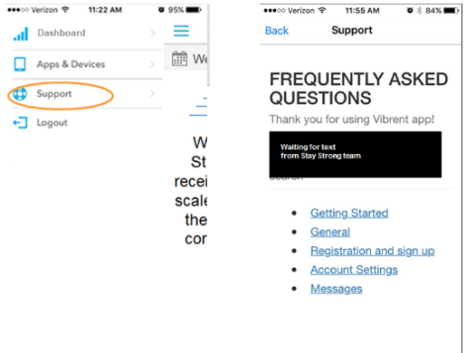

*VA Team will Develop FAQs*

**8. Apps & Devices**

|  |  |  |  |
| --- | --- | --- | --- |
| **Req No.** | **Requirement** | **Details** | **Acceptance Criteria** |
|  | Apps & Devices screen | Participants should be able to access Apps & Devices screen | 1. Participants will click on the Apps & Devices screen and be taken to the screen with options to pair the AND Weight scale and Fitbit. |
|  | Pair devices | Participants should be able to pair their devices using the app | 1. Participants will follow the steps for pairing each of the devices 2. NOTE: Screenshots of pairing instructions below. This is the same functionality as in V1 |
|  | Unpair Devices | Participants should be able to unpair their devices | 1. Participants can slide on the paired device and select Unpair to unpair their devices. |
| 4. | Wall Message | Participants should see a wall message after pairing their devices | 1. After the Weight scale has been paired, participants will see a wall message thanking them for pairing their devices. 2. After the fitbit has been paired, participants will see a wall message thanking them for pairing their devices. |

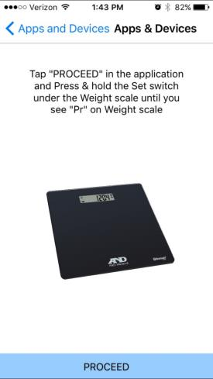

*1. Apps & Devices screen*

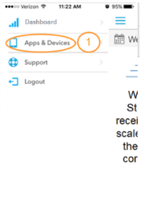 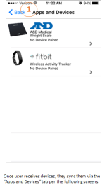

Scale pairing

*2. Pair Devices:*

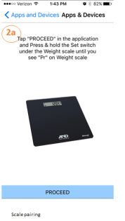 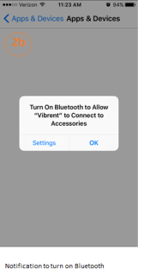 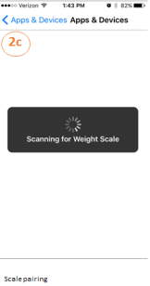

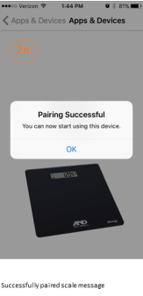 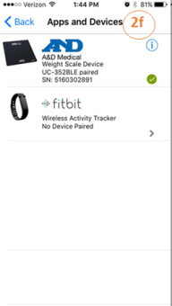 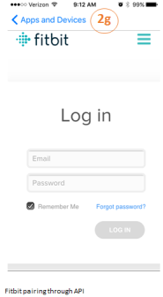

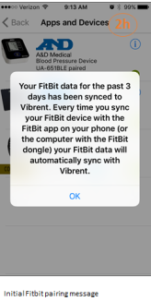 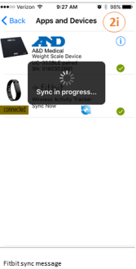 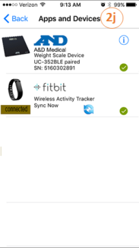

*3. Unpair Devices 4. Wall Message after pairing:*

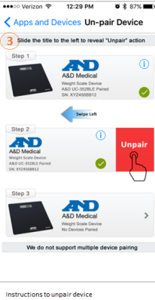 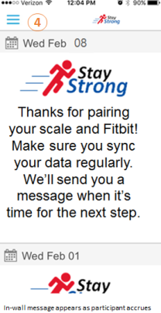

*You have successfully connected your Fitbit and scale!*

*Be sure to sync regularly. When you have synced enough data, we’ll send a message and you’ll get full access to your randomly assigned program.*

Waiting on text from Stay Strong team

**9. Participant Dashboard Requirements:**

|  |  |  |  |
| --- | --- | --- | --- |
| **Req No.** | **Requirement** | **Details** | **Acceptance Criteria** |
|  | Dashboard screen | Participants should be able to click on Dashboard option to view their data | 1. Participants will click on Dashboard option from the Hamburger menu and view their daily activity and steps. 2. Participants will click on the Category drop down and view the data for the following Measurements:    1. Active Minutes    2. Weight    3. Heart Rate    4. Steps    5. Miles    6. Stairs 3. Each of the Measurements above will have the respective data for the following:    1. Measurement    2. Goal (calculated by the system for Intervention ONLY)    3. Daily activity 4. Participants will be able to view their data in a Table format as well as Chart format 5. Chart view should be the default view 6. Participants should be able to apply Start and End Date to view the data for previous weeks    1. Start Date can only be a Sunday    2. End Date should automatically be set to end of the week which will be a Saturday |
|  | Dashboard before Randomization | Participants should not be able to see their data until they are Randomized | 1. Participants should not be able to see their synched data on the Dashboard until they have been Randomized. 2. Participants will be presented with a Splash screen during this time.    1. *You are now in the “baseline” phase. Please continue with your normal amount of activity. Sync your Fitbit and weigh yourself at least weekly. When you have sync’d enough data, you will be assigned to a program and you will be able to see your Fitbit and weight data here.* |
|  | Randomization Wall Message | Participants will receive a wall message once they have been Randomized | 1. Participants will receive a wall message once they have been Randomized.    1. Intervention Arm message (shown in the screenshot below): “Congratulations! You are now enrolled in Stay Strong with a Coach”    2. Control Arm participants will receive the following Wall Message: “Congratulations! You are now enrolled in Stay Strong” |
|  | Dashboard after Randomization | Participants should be able to see their data once they have been randomized (both Intervention and Control Arm) | 1. Participants will view their data for the current week. 2. Default Category will be Active Minutes 3. Goal will be displayed only for Active Minutes for Intervention Arm only 4. Goal line will be displayed for Active Minutes for Intervention Arm participants only. 5. Goal will not be displayed on other Categories 6. Goal and Goal line will not be displayed for any Category for Control Arm participants.   NOTE: Mocks below for Minutes and Weight. Same designs should be used for Weight, Heart Rate, Steps, Miles, and Stairs |

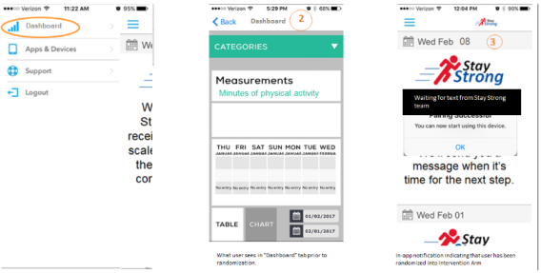

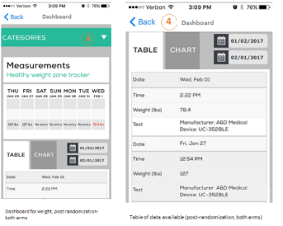

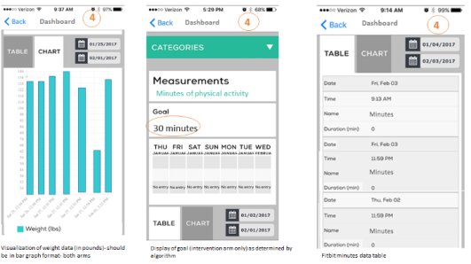

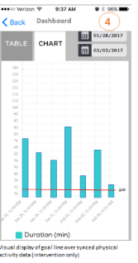

**10. Intervention Arm User Experience:**

|  |  |  |  |
| --- | --- | --- | --- |
| **Req No.** | **Requirement** | **Details** | **Acceptance Criteria** |
|  | Notification of randomization | User should be alerted, either through push notification on their lock screen, or through an in-app notification, that they’ve been randomized to the Stay Strong with Coach arm. | 1. Randomization is performed by the research team, and the arm the user is placed into is defined by what the research team chooses in the dropdown on the admin portal 2. Participants will receive a Push notification to lock screen that they have been Randomized along with the Research Arm 3. Push Notification: “Congratulations! You are enrolled in Stay Strong with Coaching” Participants will receive a wall message letting them know they have been randomized along with the Research Arm    1. Message: *Wall message:* “*You have been randomized to the Stay Strong with Coaching program. You can now see your Fitbit and weight data in the Dashboard. Your coach will contact you within the next 2-3.* |
|  | Display of goals in the Dashboard | Users should be able to click on the Dashboard from the menu and view their synced data for Fitbit activity and weight, in addition to their active minutes goal. | 1. Participants will click on Dashboard 2. Participants will select “Active Minutes” 3. Participants will see their current goal 4. Participants can look back at previous weeks of data/goals. |
|  | Display of goal line in data visualization charts | Users should be able to view a graphical display (line) of their goal for the week, imposed over their synced Active Minutes for the week | 1. Within the “Active Minutes” section of the Dashboard, Participants will see a chart of their synced Fitbit data. This chart should have as goal line for the week (Sunday-Saturdays). 2. Participants can look back at previous weeks of data/goals. |
|  | Barriers Survey | User receives a “Barriers survey” upon being randomized into the intervention arm. This survey is one question, with 11 answer choices. Users are asked to select 4 answers (they are allowed to select fewer). | 1. Upon being randomized into the Intervention Arm, user will receive a notification to take the survey. *“Please let us know possible barriers to exercising”* 2. User will click on the notification to navigate to the survey. 3. User can choose up to 4 answer choices out of the list of possibilities (multiselect). 4. User’s answer choices are stored in the system. 5. If user selects less than 4, the system should assign the system should assign answers to the user from a "generic bucket" of options given by the Stay Strong team.   NOTE: Refer to Appendix “Barrier Survey” for more details |
| 5. | Tailored messaging | The user will receive messaging based on what they (or system) selected during the barriers survey. | 1. Every other week, users receives one message related to one of the barriers they (or the system selected) 2. User should not see the same message twice within the duration of the Program   NOTE: Refer to Appendix “Messaging Schematics” for details |
| 6. | Non-tailored messaging | Per a schedule, users receive messages as defined by the research team | 1. User receives a non-tailored message on the following alternating schedule:    1. 3 times one week    2. 2 times the next week (plus one barrier message covered in #5) throughout the duration of the program.   NOTE: Refer to Appendix “Messaging Schematics” for details |
| 7. | Sync Reminder (Fitbit) | Users in the intervention arm receive a message if they have not uploaded Fitbit data in the past 7 days. | 1. Message content: "We haven't received any data from your Fitbit in the last week. Be sure to wear your Fitbit daily and be within 15 feet of your powered on computer!" 2. If there has been no Fitbit data synced over a 7 day period post-randomization, the intervention arm receives a push notification of the content above. 3. If there is no data for 15+ days, the following message should be repeated every 14 days from the previous message: We haven't received any data from your Fitbit in a while. Be sure to wear your Fitbit daily and be within 15 feet of your powered on computer! |
| 8. | Synch Reminder (Weight Scale) | Users in the intervention arm receive a message if they have not uploaded Weight  data in the past 7 days | 1. Message content: "We haven’t received any weights from your scale in the last week. Be sure to weigh yourself at least once per week with your smart phone nearby” 2. If there has been no Weight scale data synced over a 2 week period post-randomization, the intervention arm receives a push notification of the content above. 3. If there is no data for 2 weeks, the following message should be repeated every 2 weeks from the previous message: We haven’t received any weights from your scale in a while. Be sure to weigh yourself at least once per week with your smart phone nearby. |
| 9. | Goal Message | Users in the intervention arm receive a push notification when their new goal is calculated each Sunday. | 1. Message content: “Your new goal is XX Active Minutes per day this week. Please tap to see your data. You will receive a new goal next week based on the data you sync this week using your computer. 2. Intervention arm only, sent every week at 9:00 am Sunday after new goal has been calculated. 3. If user taps on the notification, it should take them to their “Active Minutes” category in the Dashboard tab. |
| 10. | Program Ending | Program End: 30 days prior to End-date | 1. You have 30 days remaining in Stay Strong with Coaching. Be sure to sync your data. At the end of your program, your account will be closed. Please call 1-800-753-3357 (Option 3) if you have any questions.    1. Notification: *You have 30 days remaining in Stay Strong* |
|  |  | Program End: 7 days prior to End-date | 1. You have 1 week remaining in Stay Strong with Coaching. Be sure to sync your Fitbit and weight data! In 1 week, your account will be closed. Please call 1-800-753-3357 (Option 3) if you have any questions.    1. Notification: *You have 1 week remaining in Stay Strong* |
|  |  | Program End: End-date | 1. Participants will be presented with a splash screen when the access the app. 2. Participants will not be able to access any other data on the app. 3. Participants will also receive a Push Notification.   Splash Screen:  **“Congratulations! Thank you for participating in Stay Strong with Coaching. Your account has now been closed. You will receive instructions via mail on how to keep using your Fitbit by connecting to Fitbit.com. Please call 1-800-753-3357 (Option 3) if you have any questions.”**  Notification: **“*Your Stay Strong program has ended”*** |

**10. Control Arm User Experience:**

|  |  |  |  |
| --- | --- | --- | --- |
| **Req No.** | **Requirement** | **Details** | **Acceptance Criteria** |
|  | View Activity & Weight data | User should be alerted, through push notification on their lock screen, and a wall message letting them know that they’ve been randomized to the Stay Strong arm. | 1. Participants will receive a Push notification to lock screen that they have been Randomized along with the Research Arm    1. *Message: “Congratulations! You are now enrolled in Stay Strong"* 2. Participants will receive a wall message letting them know they have been randomized along with the Research Arm    1. *Message:* “*You have been assigned to the Stay Strong program. You now have access to your Fitbit and weight data in the Dashboard.* Please check FAQs or call 1-800-753-3357 (Option 3) if you have any questions.*”* 3. Randomization is performed by the research team, and the arm the user is placed into is defined by what the research team chooses in the dropdown on the admin portal |
|  | View Activity & Weight data | Participants should be able to view their synched weight and fitbit data | 1. Participants will navigate to the Dashboard and view their synched data in a bar chart for each Category |
| Note | Program End Date | Program End Date=Day 395 | Program end date is 365+30 days after their start date |
| 3. | Program Ending | Program End: day 365, 9am local time | 1. You have 30 days remaining in Stay Strong. Be sure to sync your data. At the end of your program, your account will be closed. Please call 1-800-753-3357 (Option 3) if you have any questions.    1. Notification: *Your Stay Strong program will end in 30 days* |
|  |  | Program End: Day 388, 9am local time | 1. You have 1 week remaining in Stay Strong. Be sure to sync your Fitbit and weight data! In 1 week, your account will be closed. Please call 1-800-753-3357 (Option 3) if you have any questions    1. Notification: *Your Stay Strong program will end in 1 week* |
|  |  | Program End: Day 396, midnight+ | 1. Participants will be presented with a splash screen when they access the app. 2. Participants will not be able to access any other data on the app. 3. Participants will also receive a Push Notification. 4. Splash Screen:   **“Congratulations! Thank you for participating in Stay Strong with Coaching. Your account has now been closed. You will receive instructions via mail on how to keep using your Fitbit by connecting to Fitbit.com. Please call 1-800-753-3357 (Option 3) if you have any questions.”**   1. Notification: **“*Your Stay Strong program has ended”*** |

**11. Withdraw Requirements**

|  |  |  |  |
| --- | --- | --- | --- |
| **Req No.** | **Requirement** | **Details** | **Acceptance Criteria** |
|  | Withdraw from Program | Participants should be able to withdraw from the Program | 1. Participants will call the Research team to withdraw from the program 2. Admin will change the status of the participant to “Withdraw” in the Admin portal under Research Arm column 3. Once a participant is changes to Withdraw status, they will not be allowed to log in to the Program. 4. Participant will see a splash screen if they try to open the app and are withdrawn with the following text:   *You have been withdrawn from Stay Strong and your account closed. Please call 1-800-753-3357* (Option 3) *if you have any questions.* |

**12. Suspend Requirements**

|  |  |  |  |
| --- | --- | --- | --- |
| **Req No.** | **Requirement** | **Details** | **Acceptance Criteria** |
|  | Suspension from Program | Participants should be able to take a brief break from the program due to medical reasons | 1. Participants will call the Research team to let them know of the medical change and to be suspended from the program 2. Admin will change the status of the participant to “Suspend” in the Admin portal under Research Arm column 3. Once a participant is changed to Suspend status, they will be able to log in but will only be able to see a splash page with the following text:   *Your account has been suspended. Please call 1-800-753-3357* (Option 3) *if you have questions or if your doctor has cleared you to exercise again* |
|  | Medical clearance after suspension |  | 1. Admin will determine when participant is Medically Cleared to participate again 2. Admin will change Disposition to “None” 3. Status on the portal will not change if the Disposition is set to Suspended. 4. System will open content based on Research Arm |

**13. Administrative Messaging:**

|  |  |  |  |
| --- | --- | --- | --- |
| **Req No.** | **Requirement** | **Details** | **Acceptance Criteria** |
|  | Adverse Events Report Reminder | All Participants (both Arms) should receive the AE Report Reminder | 1. Participants will receive Adverse Events Report Reminder every 3 months from Start Date.   *Wall Message: “Your safety is very important to us. All changes in your medical condition should be reported to your primary healthcare provider. We also want you to report changes in your medical condition to us by telephone at 1-800-753-3357, Option 3*.”  Push notification: “Remember to report any changes in your medical condition” |
|  | Survey Reminder | All Participants (both Arms) should receive the Survey Reminder  **This is not the same as Barrier Survey. This a survey participants take in a system outside of Vibrent** | Participants will receive Survey Reminder every 6 months from Start Date. Push notification for 6- and 12-month surveys:  ***“It’s time for your next Stay Strong Survey!”***  Wall messages:  6-month survey on Participant’s Day 183:  ***“It is time for your 6-month Stay Strong Survey. Please go to www.staystrong.qualtrics.com/6-monthSurvey. You will need your Stay Strong Code. This is the same Code you use to login to Stay Strong and it’s printed in your invitation letter. Please call 1-800-753-3357 (Option 3) if you have any questions.*”**  If on the Admin Portal, "6 month survey completed" checkbox is not selected on 'Qualtrics Survey Status' column and the "Days in Program" for that Participant is 197, send the following Wall Message: ***“Reminder: If you haven’t already done so, it is time for your 6-month Stay Strong Survey. Please go to www.staystrong.qualtrics.com/6-monthSurvey. You will need your Stay Strong Code. This is the same Code you use to login to Stay Strong and it’s printed in your invitation letter. Please call 1-800-753-3357 (Option 3) if you have any questions.*”**  12-month survey on Participant’s Day 359:  ***“It is time for your 12-month Stay Strong Survey. Please go to www.staystrong.qualtrics.com/12-monthSurvey. You will need your Stay Strong Code. This is the same Code you use to login to Stay Strong and it’s printed in your invitation letter. Please call 1-800-753-3357 (Option 3) if you have any questions”***  If on the Admin Portal, "12 month survey completed" checkbox is not selected on 'Qualtrics Survey Status' column and the "Days in Program" for that Participant is 373, send the following Wall Message: ***“If you haven’t already, please go to:*** [**www.staystrong.qualtrics.com/12-monthSurvey**](http://www.staystrong.qualtrics.com/12-monthSurvey) ***to complete your survey. You will need your Stay Strong Code. This is the same Code you use to login to Stay Strong and it’s printed in your invitation letter. Please call 1-800-753-3357 (Option 3) if you have any questions.”***  If on the Admin Portal, "12 month survey completed" checkbox is not selected on 'Qualtrics Survey Status' column and the "Days in Program" for that Participant is 387, send the following Wall Message: ***“If you haven’t already, please go to:*** [**www.staystrong.qualtrics.com/12-monthSurvey**](http://www.staystrong.qualtrics.com/12-monthSurvey) ***to complete your survey. You will need your Stay Strong Code. This is the same Code you use to login to Stay Strong and it’s printed in your invitation letter. Please call 1-800-753-3357 (Option 3) if you have any questions.”***  NOTE: This survey is done outside Vibrent system. We DO NOT need to integrate with that server. |

***Appendices:***

Barriers Survey

**NOTES:**

* Administered at baseline and 6 months (results sent to study staff database)
* Individual responses determine the barrier messages they will receive (if the barriers change at 6 months, they will get messages for the new barriers then)

Instructions: *Listed below are reasons that people give to describe why they don’t get as much physical activity as they think they should. Please read through these 11 statements. From this list, select your top four barriers to being physically active.*

|  |  |
| --- | --- |
| **Barrier** | **Statement** |
| Lack of time | My day is so busy now, I just don’t think I can make the time to include physical activity in my regular schedule. |
| Social influence | My usual social activities with family or friends do not include physical activity. |
| Lack of energy | I’m too tired to get any exercise. |
| Lack of willpower/motivation | I’ve been thinking about getting more exercise, but I just can’t seem to get started. |
| Fear of injury/pain | I’m afraid I might hurt or injure myself. |
| Lack of resources | It is just too expensive. You have to take a class or join a gym or buy the right equipment. |
| Family obligations | I am too busy caring for my family to make time to exercise. |
| Weather conditions | The weather is often too unpleasant to exercise outside. |
| Depression | I feel too down, depressed, or hopeless to exercise. |
| Accountability/external motivation | I need someone to hold me accountable or I just won’t exercise. I can’t get motivated to exercise on my own. |
| Service-connected disabilities | I am not physically active due to my current disabilities. |
| No response | I have another barrier that is not listed or I prefer not to answer. |

Messaging Schematic

|  |  |  |  |  |
| --- | --- | --- | --- | --- |
| **Messaging Stream** | **Frequency** | **Total** |  |  |
| Tips (132) and barriers (24) | 3x/week, intervention only | 156 |  |  |
| Tailored goals (Steps) | 1x/week, intervention only | 52 |  |  |
| Sync reminders (Fitbit) | Intervention only, sent after 7 days with no data. | as needed |  |  |
| AE report reminders | 1x/every 3 months | 4 |  |  |
| **Times to send messages** |  |  |  |  |
| Morning (randomly choose one) | 9:30am | 10:30am | 11:00am | 11:15am |
| Afternoon (randomly choose one) | 1:00pm | 1:45pm | 2:30pm | 3:00pm |
| Evening (randomly choose one) | 4:00pm | 4:30pm | 4:45pm | 5:15pm |
| Anytime (any of the above times) |  |  |  |  |
| Other (sent before mealtimes) | 11:30am | 5:30pm |  |  |

##### **Stay Strong Goal Algorithm**

Purpose:  To provide the participants with a weekly goal based on data received from their device which slowly and gradually increases physical activity over time.

General guidelines:  For safety reasons, we never want to issue a daily goal which is more than 5 minutes greater than their previous week’s goal.  We never want to issue a goal in the absence of new data, so will instead re-issue the previous week’s goal as needed.  Each week the participant’s goal may go up, down, or stay the same.  No goal may exceed 60 minutes per day.

Day of calculation:  Goals to be calculated based on data through Saturday 11:59p local time and notification will be pushed at 9:00am of their respective time zone Sunday.

Valid week for calculation:  the most **recent** 7 consecutive days where at least 5 of the 7 days have valid data.  To be a valid day, a day must have:

* + 5 minutes of light activity

FIRST GOAL CACULATION:

* + The average of most recent valid week is calculated, where non valid days are dropped and the remaining total is averaged.  (AVG)
  + AVG + 5 Minutes, rounded to the nearest integer  = Pre Goal (PreG)
  + For the first goal calculation, PreG is the first Goal (G)

**Example:**

|  |  |  |
| --- | --- | --- |
| **Date** | **Active Minutes** | **Minutes of Light Activity** |
| **12/12/2015** | 13 | 172 |
| **12/11/2015** | 9 | 277 |
| **12/10/2015** | 24 | 151 |
| **12/09/2015** | 0 | 4 |
| **12/08/2015** | 35 | 173 |
| **12/07/2015** | 8 | 109 |
| **12/06/2015** | 0 | 3 |
| **12/05/2015** | 0 | 0 |

YELLOW is the valid week for calculation

GREEN are the valid days

AVG [(13 + 9 +24 +35 + 8)/5]   =17.8

PreG = Int(17.8 +5)  = 23

G = 23 Minutes daily

SUBSEQUENT GOAL CALCULATIONS:

* + The average most recent valid week is calculated, where non valid days are dropped and the remaining totaled is averaged.  (AVG)
  + If no new data since last calculation then issue previous G as new goal.  Stated another way:  If no new data à G = last week’s goal
  + If new data, we want to ensure that the new goal is not more than 5 minutes greater than the previous goal.  Therefore, we add 5 minutes to the previous G to make MaxG, which is used as a comparison for this week:
    - If PreG<MaxG then G=Preg
    - If PreG>MaxG then G=MaxG

**Example One:**

|  |  |  |
| --- | --- | --- |
| **Date** | **Active Minutes** | **Minutes of Light Activity** |
| **12/20/2015** | 0 | 0 |
| **12/19/2015** | 0 | 6 |
| **12/18/2015** | 12 | 120 |
| **12/17/2015** | 0 | 158 |
| **12/16/2015** | 0 | 0 |
| **12/15/2015** | 0 | 7 |
| **12/14/2015** | 0 | 0 |
| **12/13/2015** | 6 | 45 |

YELLOW is the valid week for calculation

GREEN are the valid days

AVG [(0 +12 +0 +0 +6)/5] = 3.6

PreG = Int(3.6+5) = 9

MaxG = 28 Minutes (23 from first goal example above, plus 5 minutes)

PreG < MaxG

G=9 Minutes

**Example Two:**

|  |  |  |
| --- | --- | --- |
| **Date** | **Active Minutes** | **Minutes of Light Activity** |
| **12/20/2015** | 0 | 6 |
| **12/19/2015** | 22 | 120 |
| **12/18/2015** | 36 | 158 |
| **12/17/2015** | 0 | 0 |
| **12/16/2015** | 40 | 300 |
| **12/15/2015** | 0 | 7 |
| **12/14/2015** | 30 | 200 |

YELLOW is the valid week for calculation

GREEN are the valid days

AVG [(0 + 22 +36 + 40 + 0+ 30)/6] = 26.33

PreG =Int(26+5)=31

MaxG = 28 (23 from first goal example, plus 5)

PreG > MaxG

G= 28

**In summary:**

* If new data
  + AVG =
  + PreG = Int(AVG +5)
  + MaxG = Last week’s goal +5
    - If PreG<MaxG àG=PreG
    - If PreG>MaxG àG=MaxG
* If no new data then G = last week’s goal

Process Flows (note that Baseline goal can only be generated once sufficient amount of data has been sync’ed; see Stay Strong Goal Algorithm above):

